Memorial and Thanksgiving

to celebrate the life of

Graham Leah

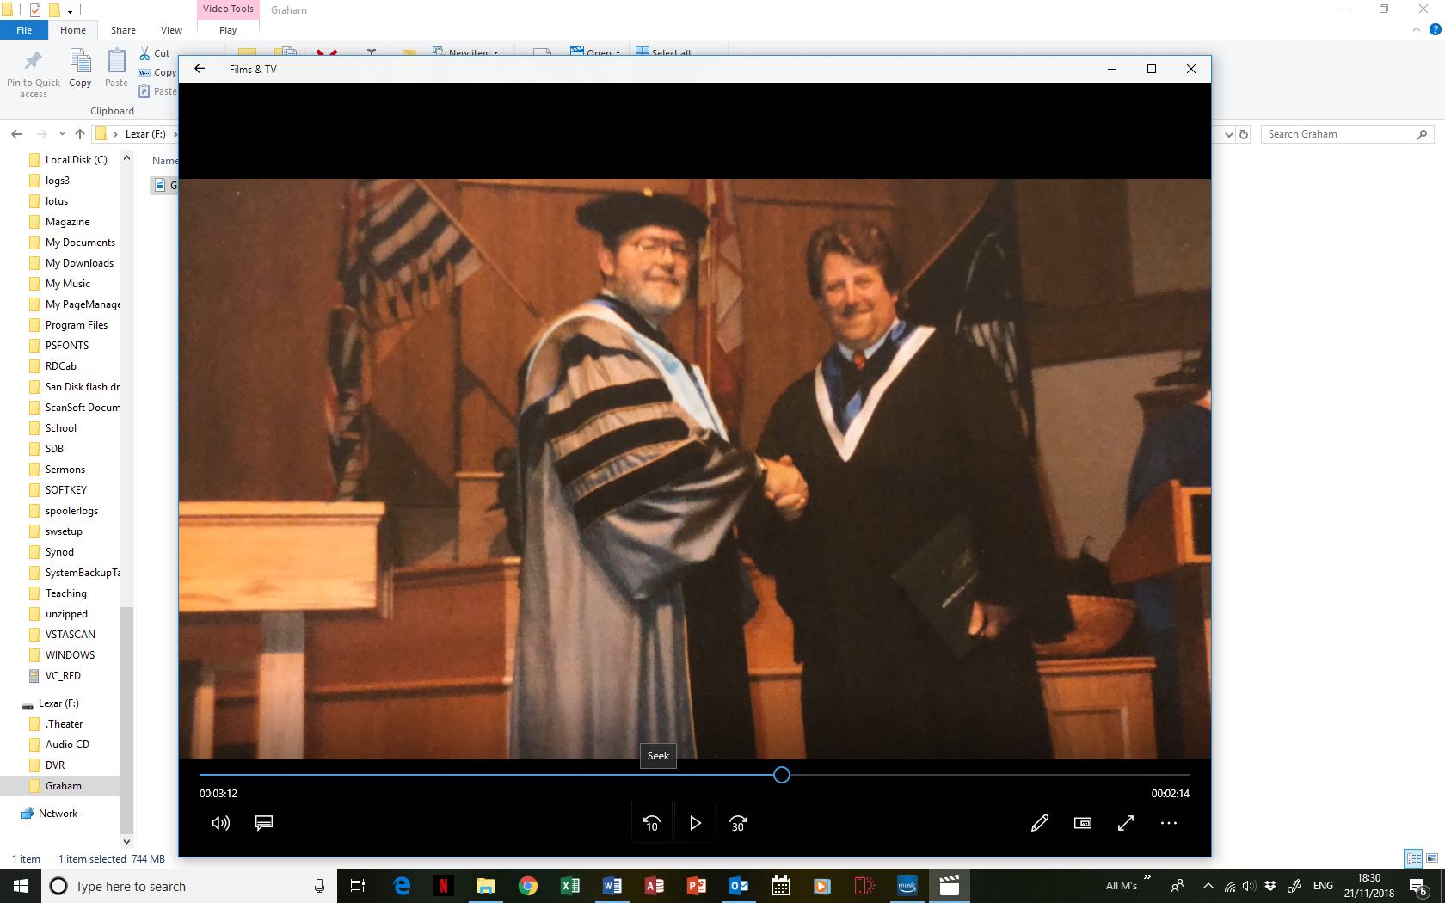

25th April 1956 – 24th October 2018

Order of Service

Opening music: *I’ll be seeing you* by Frank Sinatra

#### **Introduction and Opening Prayers**

**All:** **Merciful Father, hear our prayers and comfort us; renew our trust in your Son, whom you raised from the dead; strengthen our faith that all who have died in the love of Christ will share in his resurrection; who lives and reigns with you, in the unity of the Holy Spirit, one God, now and for ever.**  **Amen**

**Hymn:** The Lord's my Shepherd, I'll not want;

he makes me down to lie -

in pastures green; he leadeth me -

the quiet waters by.

My soul he doth restore again,

and me to walk doth make -

within the paths of righteousness,

e'en for his own name's sake.

Yea, though I walk through death's dark vale,

yet will I fear no ill;

for thou art with me, and thy rod -

and staff me comfort still.

My table thou hast furnished

in presence of my foes;

my head thou dost with oil anoint,

and my cup overflows.

Goodness and mercy all my life

shall surely follow me;

and in God's house, for evermore

my dwelling place shall be.

**The Gospel Reading:** John 14. 1-6

**The Address:** including eulogy by Brian

**A Pictorial Reflection**

**The Prayers and Lord’s Prayer:**

*After “Lord, in your mercy”, please respond by saying: “****Hear our prayer”***

## After the final section:

All: God of mercy, entrusting into your hands all that you have made and rejoicing in our communion with all your faithful people, we make our prayers through Jesus Christ our Saviour. Amen.

Our Father, who art in heaven, hallowed be thy name; thy kingdom come; thy will be done; on earth as it is in heaven. Give us this day our daily bread. And forgive us our trespasses, as we forgive those who trespass against us. And lead us not into temptation; but deliver us from evil. For thine is the kingdom, the power and the glory, for ever and ever. Amen.

**The Commendation:** *(please remain standing)*

Priest: Let us commend Graham to the mercy of God our Maker and Redeemer.

*After the prayer of commendation:*

**All: Heavenly Father, in your Son Jesus Christ you have given us a true faith and a sure hope. Strengthen this faith and hope in us all our days, that we may live as those who believe in the communion of saints, the forgiveness of sins and the resurrection to eternal life; through Jesus Christ our Lord. Amen.**

Exit music:  *Forever Young* by Rod Stewart



